Results from Pilot Assessment of
Critical Thinking Spring 2010

Summary
A pilot assessment of the Critical Thinking core competency was conducted in six different courses (STS 101, DMI 120, ACC 101, MATH 150, PHIL 101, and PHIL 111) during the Spring 2010 semester. A total of 125 students were assessed. The assessment tool used was the Critical Thinking rubric (see Appendix A) chosen by the Critical Thinking Subcommittee of the Learning Outcomes Assessment Committee (LOAC). The rubric was used to assess one assignment in each class. The rubric was not normed by the faculty members prior to use, leading to possible variations in assessment and lessened reliability of results. The skills assessed on the Critical Thinking Rubric were:
- Gathers and analyzes data, ideas, and/or concepts from multiple sources
- Applies information related to formulas, theories, procedures, principles or themes
- Presents multiple solutions, positions or perspectives
- Draws well supported conclusions
- Synthesizes ideas into a coherent whole
- Participates in the self reflection/ assessment process
Students were assessed on four competency levels, Beginning, Developing, Competent, and Accomplished. Students were considered at or above competency level if they were assessed as being at the Competent or Accomplished level.
Several results are presented in this report.
- The percentage of students at each competency level for each skill
- The percentage of students above and below competency for each skill
- Number of students in each competency level overall
- Percentage of students above and below competency overall
- Mean and median scores for students for each skill and for overall competency scores
- Individual student scores on each skill
- Individual student overall competency scores
- The number of students at each competency level by skill for each class section
These results are displayed on the accompanying tables, graphs, and appendices.
Findings show:

Results
For Skill 1, “Gathers and analyzes data, ideas, and/or concepts from multiple sources,” 41 students (33 %) were considered Accomplished, 62 students (50 %) were Competent, 12 students (9 %) were Developing, and 10 students (8 %) were on a Beginning level. Therefore, 83 % of students were at or above competency level. (See Figure 1).
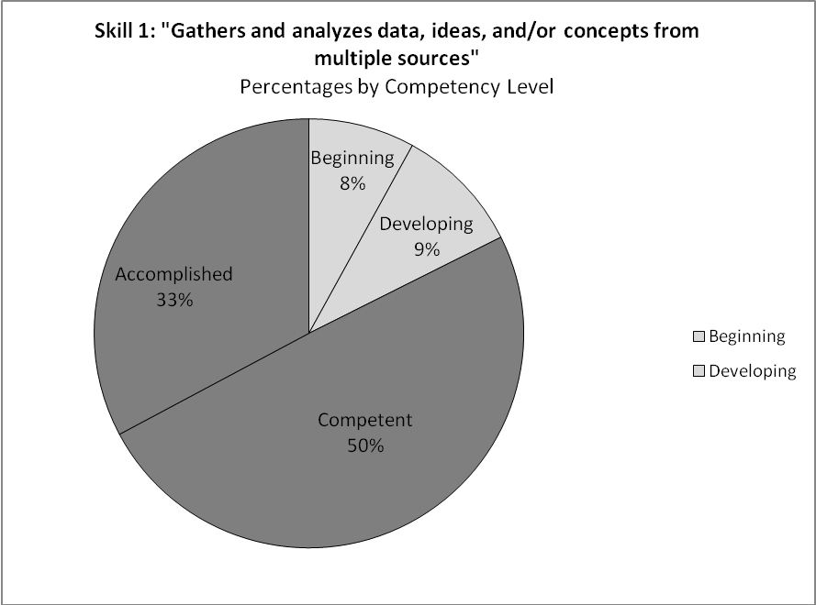
Figure 1
Above Competency
Below Competency

On Skill 2, “Applies information related to formulas, theories, procedures, principles or themes,” 40 students (32 %) were considered Accomplished, 57 students (46 %) were Competent, 17 (13 %) were Developing, and 11 (9 %) were considered Beginning. From this skill, 78 % of students were at or above competency level. (See Figure 2).

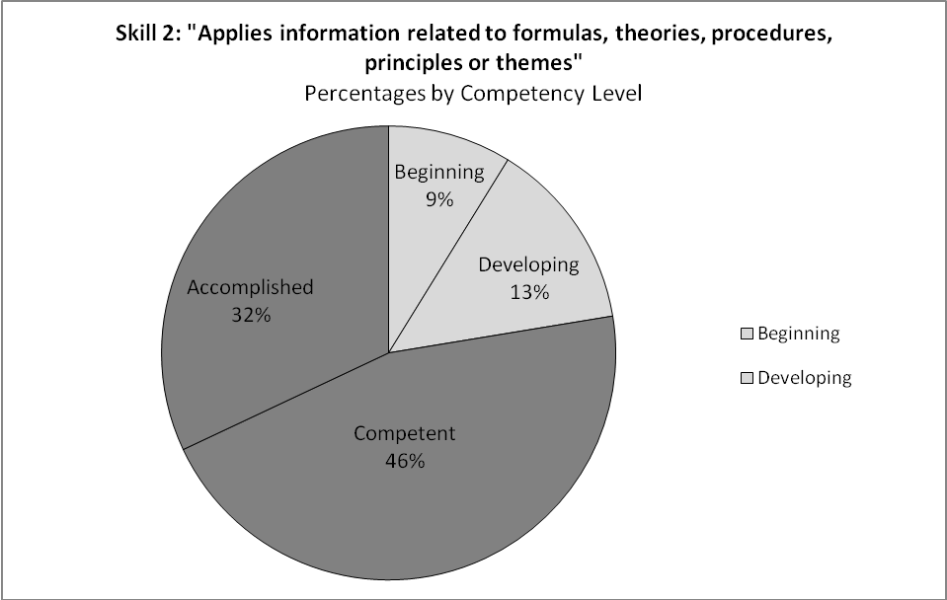
Figure 2
Above Competency
Below Competency

On Skill 3, there were 33 students (26 %) considered Accomplished, 33 (26 %) were Competent, 37 (30 %) were Developing, and 22 (18 %) were Beginning for Skill 3, “Presents multiple solutions, positions or perspectives.” On this skill, 52% of students were assessed as at or above competent. (See Figure 3).
Figure 3
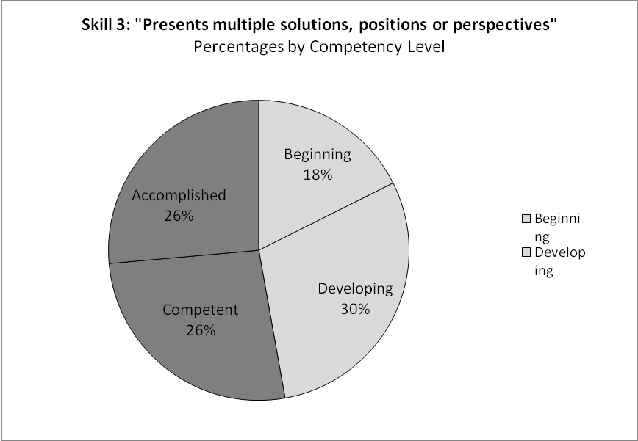
Above Competency
Below Competency

Next, for Skill 4, “Draws well supported conclusions,” 37 students (30 %) were considered to be Accomplished, 50 (40 %) students were Competent, 18 (14 %) were Developing, 20 (16 %) were on a Beginning level, for a total scoring of 70 % at or above competency level. (See Figure 4).
Figure 4

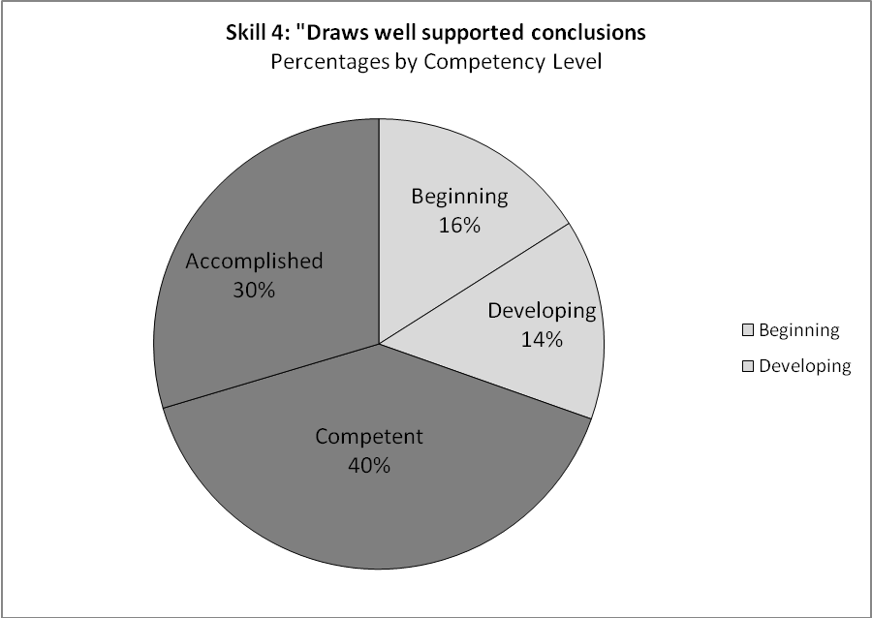
Above Competency
Below Competency

On Skill 5, “Synthesizes ideas into a coherent whole” 36 students (29%) were assessed as being Accomplished, 47 (38 %) were Competent, 25 (21 %) were Developing, and 15 (12%) were assessed as Beginning. There were 67 % of students assessed at or above competency level. (See Figure 5).
Figure 5

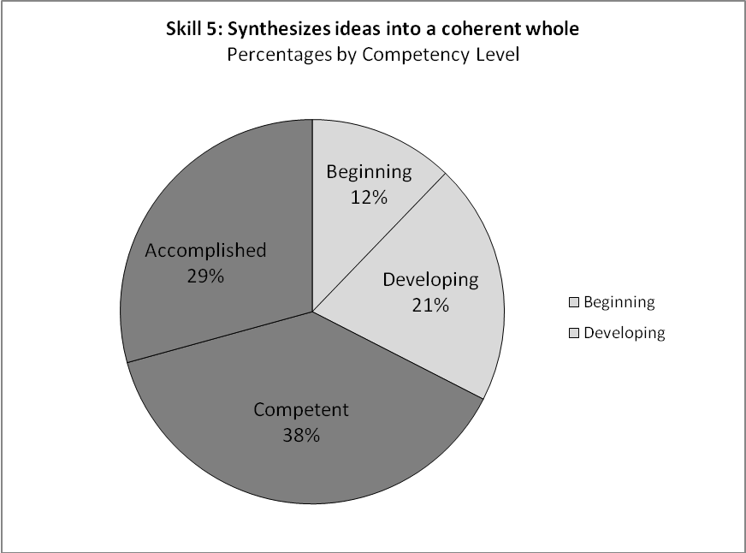
Above Competency
Below Competency

Finally, on Skill 6, “Participates in the self reflection/assessment process” 38 students (31 %) were considered Accomplished, 50 (40 %) were Competent, 23 (19 %) were Developing, and 13 (10%) students were on a Beginning level. Therefore 71 % of students were at or above competency level for the skill. (See Figure 6).
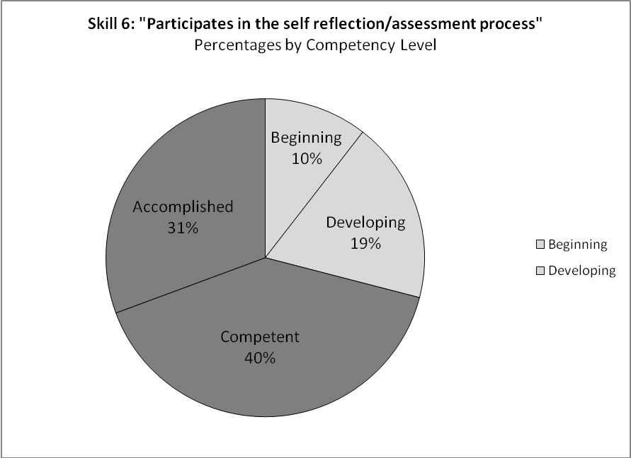
Figure 6
Above Competency
Below Competency
The findings show that overall, a majority of the students are performing above competency in each skill for Critical Thinking (See Figure 7). The highest percentages of students are above competency on Skill 1 “Gathers and analyzes data, ideas, and/or concepts from multiple sources” while the least amount of students were above competency for Skill 3 “Presents multiple solutions, positions or perspectives.”

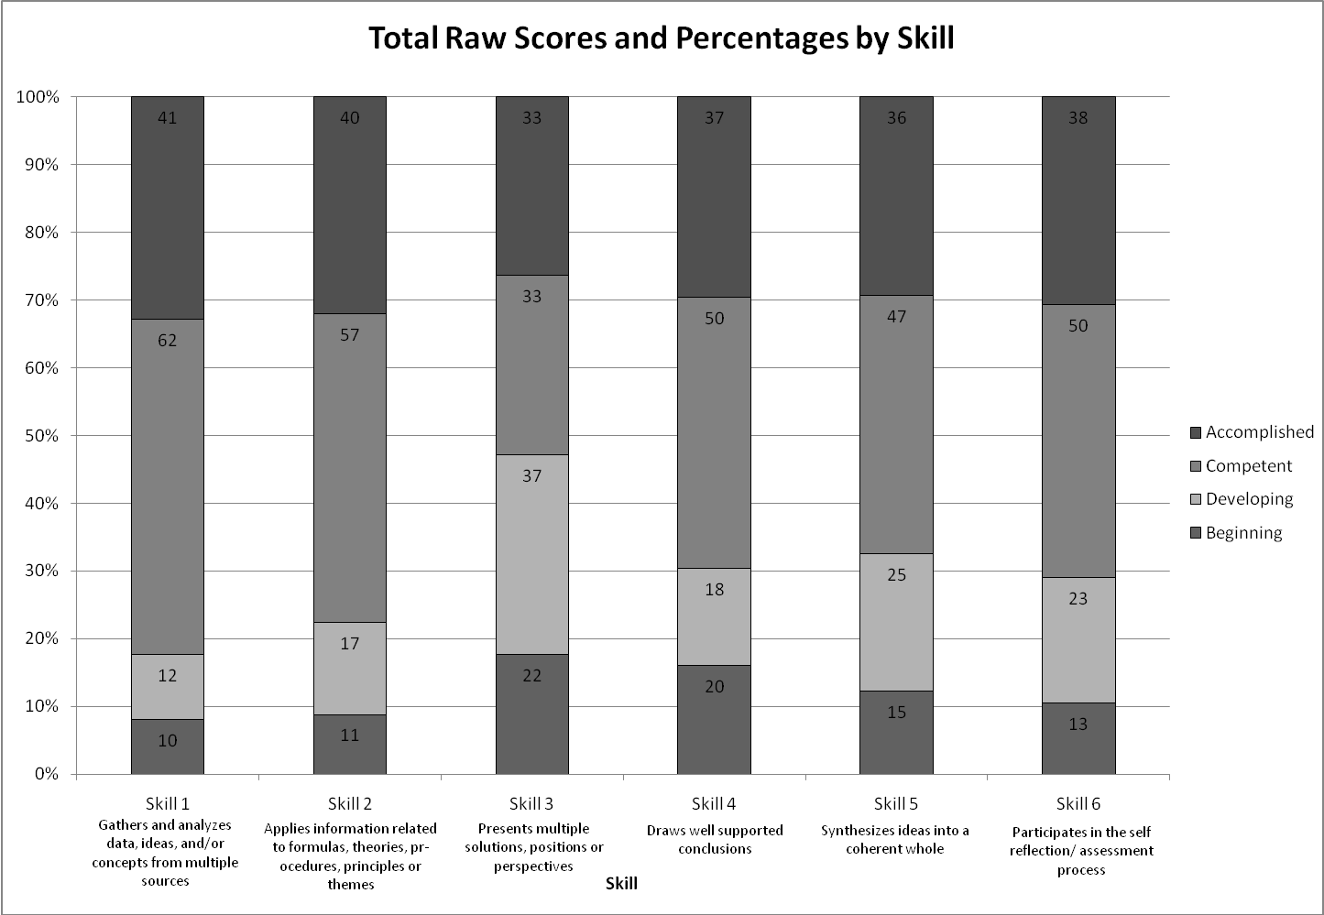
Figure 7
Each competency level was assigned a number, Beginning=1, Developing=2, Competent=3, and Accomplished=4. The average and median competency score was calculated for each skill on the Critical Thinking Rubric as well as an overall score for all students. For Skill 1 “Gathers and analyzes data, ideas, and/or concepts from multiple sources,” the average score was a 3.08, with a median of 3.00. The average score for Skill 2, “Applies information related to formulas, theories, procedures, principles or themes,” was 3.02 with a median score of 3.00. For Skill 3, “Presents multiple solutions, positions or perspectives,” the average score was 2.62 with a median score of 3.00. For Skill 4, “Draws well supported conclusions,” the average was a 2.82, with a median of 3.00. Skill 5, “Synthesizes ideas into a coherent whole,” had an average score of 2.85 and a median of 3.00. For Skill 6, “Participates in the self reflection/assessment process,” 2.92 was the average score with a corresponding median of 3.0. For all students, there was an average score of 2.89 for all competencies with a median score of 2.83. All average and median scores correspond to a skill level of Competent on the Critical Thinking Rubric.
Overall Critical Thinking competency scores were calculated by averaging competency levels across skills for each student. A student was considered at a Beginning level with an average score between 1-1.75, Developing students scored between 1.76 and 2.5, students rated as Competent scored between 2.51 and 3.25, while Accomplished students had a competency score of 3.26-4.00. Out of the 125 students, 34 % were considered Accomplished, 31 % were considered Competent, 26 % were rated as Developing, and 9 % were on a Beginning level, for all competencies combined. (See Figure 8). Overall, 65 % of students were at or above competency level in Critical Thinking, while the remaining 35% of students were below competency level. (See Figure 9).
Figure 8
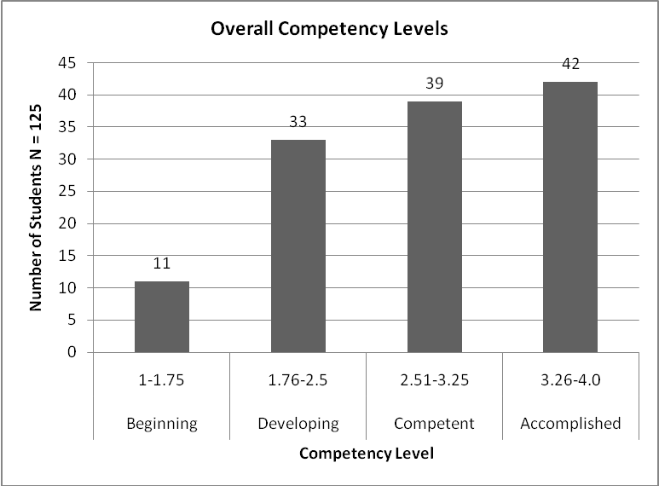
Figure 9
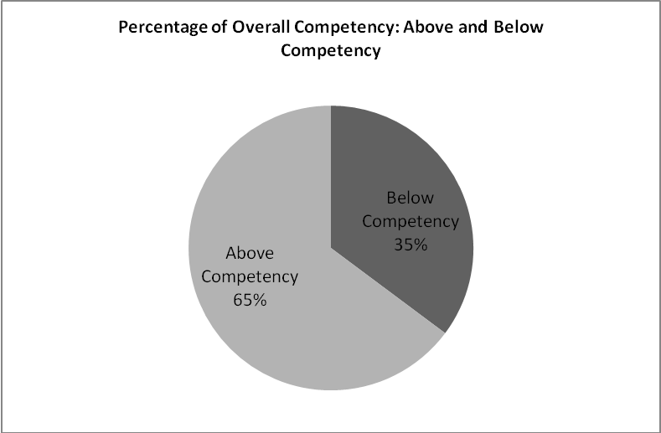

Interpretations of Results and Recommendations
An additional analysis was done to see if there was a correlation between the critical thinking score (X) and the number of credits completed (Y). This analysis showed that there was no relationship between these two variables.
Faculty feedback (See Appendix C) showed some dissatisfaction with the Critical Thinking rubric itself. In particular, many felt that the rubric would be useful “as an overall tool for looking at what we would hope to achieve over the course of the curriculum,” however, it did not work well in relation to their particular assignment. In addition, some faculty members who ended up not using the rubric, but offered their feedback, mentioned that the rubric is not universal across all disciplines and course levels. For example, students in an introductory course may never reach the “Accomplished” level until they are in a higher-level course. One faculty member mentioned that “the Accomplished category seems too ambitious for two years of study.” Another faculty member, who did not use the rubric, felt that it was too limited in the sense that it could not be used for all types of assignments, and that a broader and more universal rubric would be more effective for the faculty in assessing Critical Thinking abilities.
Although some faculty expressed that they did not think any of their students could reach the ‘Accomplished’ level, other faculty felt that their students achieved this level. Results showed that 34% of students assessed had an overall competency level of “Accomplished”. It is important to note that most of these students were coming from Philosophy 101 (Introduction to Philosophy) and Philosophy 111 (Critical Thinking). In these courses, which are within a discipline that explicitly teaches critical thinking skills, 55% and 67% of students, respectively, were marked at the “Accomplished” level averaged across all skills, compared to 9%, at the highest, for the other four courses.

Appendix A: Rubric for Critical Thinking
COMMUNITY COLLEGE OF PHILADELPHIA
RUBRIC FOR ASSESSMENT OF CRITICAL THINKING ACROSS THE CURRICULUM
2/2/10 (adapted from Valencia)
Thinking Indicators | Beginning (1) | Developing (2) | Competent (3) | Accomplished (4)
Gathers and analyzes data, ideas, and/or concepts from multiple sources | - Copies information, often inaccurately, incompletely, or omits relevant information  - Uses only one source | - Reports information – paraphrases. May have minor inaccuracies, irrelevancies or omissions | - Presents information accurately and appropriately. Uses multiple sources. | - Blends multiple sources. Interprets accurately, appropriately and in depth in new contexts.
Applies information related to formulas, theories, procedures, principles or themes | - Labels formulas, theories, procedures, principles or themes inappropriately, inaccurately, or omits them | - Uses appropriate formulas, theories, procedures, principles or themes with minor inaccuracies | - Applies formulas, theories, procedures, principles, or themes appropriately and accurately in familiar context | - Employs formulas, theories, procedures, principles or themes accurately, appropriately and or creatively in new contexts
Presents multiple solutions, positions or perspectives | - Identifies a single solution or resolution or fails to present one | - Identifies simple solutions or perspectives with minor inaccuracies | - Describes two or more solutions, resolutions, positions, or perspectives accurately | - Explains accurately and thoroughly, multiple solutions, resolutions, positions, or perspectives that balance opposing views of an issue
Draws well supported conclusions | - Proposes a conclusion or resolution that is inconsistent with evidence, illogical or omits conclusion altogether | - Offers an abbreviated or overly simple conclusion that is mostly consistent with evidence and has minor inaccuracies | - Organizes a conclusion that is complete, logical and consistent with evidence | - Creates an independent judgment that is reflected in the conclusion or solution. Well supported by evidence and logic.
Synthesizes ideas into a coherent whole | - Lists ideas or expresses solutions in a disjointed manner, no order | - Uses a simple pattern to organize solutions | - Connects ideas or develops solutions in a clear and orderly manner | - Integrates ideas into solutions that are clear and cohesive.
Participates in the self reflection/assessment process | - Unable to identify major strengths and weaknesses in work  - Does not seek and/or resists feedback on work | - Attempts to identify strengths and weaknesses in work  - Accepts feedback to improve work | - Identifies strengths and weaknesses in work  - Seeks assistance when needed to improve work | - Self-identifies strengths /weaknesses in work and makes efforts to improve  - Uses feedback to increase self awareness, improve overall research methods, and enhance learning

Appendix B: Section by Section Results
Appendix B
Individual Student Scores by Skill Level and Overall Competency Scores
Section by Section Results: Section 1
Section 1 | Beginning | Developing | Competent | Accomplished | Mean Score of Skill
N=18
Gathers and analyzes data, ideas, and/or concepts from multiple sources | 4 | 2 | 9 | 3 | 2.61
Applies information related to formulas, theories, procedures, principles or themes | 3 | 7 | 5 | 3 | 2.44
Presents multiple solutions, positions or perspectives | 3 | 11 | 1 | 3 | 2.22
Draws well supported conclusions | 2 | 9 | 7 | 0 | 2.28
Synthesizes ideas into a coherent whole | 4 | 9 | 4 | 1 | 2.11
Participates in the self reflection/assessment process | 4 | 11 | 2 | 0 | 1.88
 |  | Mean Overall Competency Score: |  |  | 2.26
Note: Based on STS101 papers from Spring 2010

Section by Section Results: Section 2
Section 2 | Beginning | Developing | Competent | Accomplished | Mean Score of Skill
N=19
Gathers and analyzes data, ideas, and/or concepts from multiple sources | 0 | 0 | 19 | 0 | 3.00
Applies information related to formulas, theories, procedures, principles or themes | 1 | 0 | 18 | 0 | 2.89
Presents multiple solutions, positions or perspectives | 14 | 1 | 4 | 0 | 1.47
Draws well supported conclusions | 13 | 1 | 5 | 0 | 1.58
Synthesizes ideas into a coherent whole | 5 | 9 | 5 | 0 | 2.00
Participates in the self reflection/assessment process | 2 | 7 | 10 | 0 | 2.42
 |  | Mean Overall Competency Score: |  |  | 2.23
Note. Based on assignment from DMI119

Section by Section Results: Section 3
Section 3 | Beginning | Developing | Competent | Accomplished | Mean Score of Skill
N=22
Gathers and analyzes data, ideas, and/or concepts from multiple sources | 0 | 2 | 20 | 0 | 2.91
Applies information related to formulas, theories, procedures, principles or themes | 0 | 2 | 20 | 0 | 2.91
Presents multiple solutions, positions or perspectives | 0 | 12 | 10 | 0 | 2.45
Draws well supported conclusions | 0 | 0 | 22 | 0 | 3.00
Synthesizes ideas into a coherent whole | 0 | 0 | 20 | 0 | 3.00
Participates in the self reflection/assessment process | 0 | 0 | 22 | 0 | 3.00
 |  | Mean Overall Competency Score: |  |  | 2.88
Note: Based on ACC101 assignment from Spring 2010

Section by Section Results: Section 4
Section 4 | Beginning | Developing | Competent | Accomplished | Mean Score of Skill
N=7
Gathers and analyzes data, ideas, and/or concepts from multiple sources | 1 | 0 | 6 | 0 | 2.71
Applies information related to formulas, theories, procedures, principles or themes | 2 | 2 | 3 | 0 | 2.14
Presents multiple solutions, positions or perspectives | 0 | 4 | 3 | 0 | 2.43
Draws well supported conclusions | 0 | 3 | 4 | 0 | 2.57
Synthesizes ideas into a coherent whole | 1 | 2 | 3 | 1 | 2.57
Participates in the self reflection/assessment process | 2 | 0 | 5 | 0 | 2.43
 |  | Mean Overall Competency Score: |  |  | 2.48
Note: Based on MATH150 assignment from Spring 2010

Section by Section Results: Section 5
Section 5 | Beginning | Developing | Competent | Accomplished | Mean Score of Skill
N=31
Gathers and analyzes data, ideas, and/or concepts from multiple sources | 5 | 6 | 2 | 18 | 3.06
Applies information related to formulas, theories, procedures, principles or themes | 5 | 5 | 4 | 17 | 3.06
Presents multiple solutions, positions or perspectives | 5 | 5 | 6 | 15 | 3.00
Draws well supported conclusions | 5 | 5 | 4 | 17 | 3.06
Synthesizes ideas into a coherent whole | 5 | 4 | 5 | 17 | 3.10
Participates in the self reflection/assessment process | 5 | 4 | 4 | 18 | 3.13
 |  | Mean Overall Competency Score: |  |  | 3.07
Note: Based on Philosophy 101 Final Exam Spring 2010

Section by Section Results: Section 6
Section 5 |  | Beginning | Developing | Competent | Accomplished | Mean Score of Skill
N=28
Gathers and analyzes data, ideas, and/or concepts from multiple sources |  |  | 2 | 6 | 20 | 3.64
Applies information related to formulas, theories, procedures, principles or themes |  |  | 1 | 7 | 20 | 3.68
Presents multiple solutions, positions or perspectives |  |  | 4 | 9 | 15 | 3.39
Draws well supported conclusions |  |  |  | 8 | 20 | 3.71
Synthesizes ideas into a coherent whole |  |  | 1 | 10 | 17 | 3.57
 | Participates in the self reflection/assessment process |  | 1 | 7 | 20 | 3.68
 |  |  | Mean Overall Competency Score: |  |  | 3.61
 | Note: Based on Philosophy 111: Critical Thinking Final Exam Spring 2010

Appendix C: Faculty Feedback
Appendix B
Individual Student Scores by Skill Level and Overall Competency Scores

The following questions were asked to the faculty members who volunteered to use the Critical Thinking Rubric. Not all faculty members ended up completing the rubric.

Feedback Questions:
- The content of the rubric--were the categories/wording helpful? Do you have any suggestions for changes in wording?
Feedback from faculty who used the rubric:
- I thought the content and categories were helpful.
- I think the rubric is well-worded overall, but I have attached a copy of what I normally use and discuss with my critical thinking students.
- I found the rubric to be much too complex and advanced for evaluating an assignment in a beginning class in our curriculum. Many of the students are coming in at what you describe as the "beginning" level, and some at the "developing level." In addition, the Thinking Indicator "Applies information related to formulas, theories, procedures, principles or themes” is much too complex in its meaning and needs to be unpacked for practical use in a particular discipline.
The rubric you have is good as an overall tool for looking at what we would hope to achieve over the course of the curriculum, although the "Accomplished" category seems too ambitious for two years of study. However, it is too complex for use in a particular course with a particular assignment. It needs to be tailored specifically to a particular assignment and to where we hope the student will achieve at the end of that particular assignment. Each assignment must be explicit in terms of how the Thinking Indicators are to be achieved by students. It then makes it easier to develop a grading system consistent with that. If each course contains some activities that support critical thinking, we can have some assurance that we are moving towards achieving critical thinking goals. However, it you want to make an overall judgment comparing the time of entrance in the curriculum to the time of exit, then it would require some type of global assessment tool.
- The levels in the rubric are so close that the distinctions are almost arbitrary as to where a student falls. This will result in inconsistency, not only from one faculty member to another, but even as a single faculty member is evaluating a class. There are going to be issues with both validity and reliability unless an objective measure can be developed.
- #1 – I didn’t have multiple sources for this assignment, maybe this would apply better to a course assessment. #6 – I added a self-assessment survey to this assignment. Perhaps self assessment would be more valuable in a course assessment
- Helpful in grading, no suggestions for changes in wording
Feedback from faculty who did not use the rubric:
- The results were slow, and I cannot stay that any of my students actually “Accomplished” the goals. Part of the problem as a writing teacher is that 098 and 101 students have such limited vocabularies that it is difficult for me to find “clear and cohesive.”
- I think my “big picture” concern is that the rubric seems too limited in two ways. One, it seems to assume a particular type of assignment/project – a research paper/project perhaps? I would want the rubric to be able to include other types of assignments. Second, the rubric excludes some elements of critical thinking that seem important – the ability to interrogate one’s own or an author’s assumptions, for example. Some other things that would get me stuck in using this rubric include:
  - “Gathers and analyzes data, ideas, and/or concepts from multiple sources” – multiple sources, why?
  - “Participates in the self reflection/assessment process” – I’m not sure why this dimension is here at all.
  - Slippery language across standards is confusing. Two examples:
    - “Synthesizes ideas into a coherent whole” does not seem to connect fully with the standards which seem more focused on solutions.
    - “Applies information related to formulas, theories, procedures, principles or themes” – the verbs shift across the criteria from “uses” to “applies” to “employs”
- Was the rubric useful in helping your students achieve the desired learning outcomes for the course? Please comment:
Feedback from faculty who used the rubric:
- The rubric was useful in helping my students achieve the desired learning outcomes for this particular assignment. However, I would like to incorporate this type of rubric for more assignments throughout the semester in order to achieve the desired learning outcomes for the entire course.
- Yes, in the Critical Thinking (PHIL 111) and Intro to Philosophy (PHIL 101) classes, I used the rubric; it helped focus students on the key element of critical thinking.
- When students were given the modified rubric, and it was discussed, it was clear that it was too abstract for them. If I had re-written the assignment to have students see the operations they needed to achieve an Indicator at a certain level, then it would have been very effective. For example, "Gathers and analyzes data, ideas, and concepts from multiple sources" could be put in terms of "In completing assignment X, you must find a minimum of three different sources. You must paraphrase the information from each source and be careful to accurately reflect the thinking of each author. I would then have an example of what I am asking.
- Not really. The course itself has as its goal the development of scientific reasoning skills, which are strongly linked to critical thinking. The development of skills is a major struggle throughout the semester.
- I learned that all but one student was competent in analyzing data and using the x-ray tube rating chart, however, problem solving with that data is a higher level of thinking and many are not there yet. I will incorporate more “thinking” scenarios in DMI 120.
- Somewhat
Feedback from faculty who did not use the rubric:
- I use rubrics on individual papers, usually grading on ten points each for Thesis, Examples, Structure, Development/Explanations/Context and Grammar. Students get higher grades as the semester progresses, especially when they begin to revise essays with a seriousness of purpose.

- Student response to the rubric
Feedback from faculty who used the rubric:
- Most students seemed to have a positive response to the rubric. Some students appeared confused by the rubric and its intended purpose.
- Overall, students found it quite helpful for our classes, but some had doubts about its usefulness in other classes.
- They could not identify with it so they ignored it.
- They were more concerned with the implementation and use rather than the actual skills themselves.
- As a reward, I gave the students added points toward their cumulative final exam score for this course. They were only interested in the points, they didn’t care to review the assignment or the rubric.
- N/A, didn’t really get a chance to go over the rubric with students
Feedback from faculty who did not use the rubric:
- They still think I’m the toughest grader in the world had have difficulty embracing the concept that grades are not given, but earned…

5) Other feedback you wish to provide
Feedback from faculty who did not use the rubric:
- Overall, I believe this is a valuable tool for assessing critical thinking. However, in my view, the level of critical thinking in an introduction accounting course is limited as compared to a liberal arts course such as philosophy or sociology. The focus of Accounting 101 is to learn the rules of accounting and how to prepare financial statements. I believe this rubric would be more applicable to higher level accounting courses, such as Accounting 201 and Accounting 202 (Intermediate Accounting I and II), where students are encouraged to think critically about accounting standards. The assignment that I gave my Accounting 101 students did not lend itself to the “accomplished” categories. As an example, the first row under the accomplished categories states “blends multiple sources, interprets accurately, appropriately and in depth in new contexts”. Although the problem that I assigned could be viewed as a critical thinking problem, all of the information needed to complete the assignment could be found within the problem itself. And thus students did not need to utilize multiple sources of information to answer the question.
- I noticed that some of the categories did not apply quite right to the assignment, especially the part about self reflection.
- The rubric is on the right track, but work is needed to make it of practical use in different level courses. I think it will also require some assignments that require several drafts, so students learn how to develop such skills.
- Can a “level” be determined if a student is a mix?
- None of my students reached the accomplished level in any category. They are in the 3rd semester of an 8 semester program or maybe my assignment didn’t allow them to go above and beyond competent. I could expect they’ll score higher as level 2 students with more academic and clinical experience.
- This will be helpful next time
Feedback from faculty who did not use the rubric:
- I think I could apply YOUR rubric for Critical Thinking in the fall; mine may have been too specific. I DO like the seeking feedback one and think that is our students’ weakest point.
- For example, the outcome “present multiple solutions, positions or perspectives” is not always a reasonable thing to do in Math. First of all, some problems have just one possible (reasonable) solution. In other situations, we are trying to teach students to select the best solution and encourage them to do so. I would change this outcome to “presents multiple OR optimal solutions…” The last outcome in the rubric also seems to me difficult to evaluate in a calculus course.

